**HOSPITAL MANAGING QR CODE WEB APPLICATION USING DJANGO AND PYTHON**

*Ramees AR [1], Akhil PS [2], Amrutha MA [3], Fathima Jabbar [4], Elia Nibia [5]*

*B.Tech Students[1][2][3][4], Associate Professor[5]*

*Department of Computer Science & Engineering*

*KMEA Engineering College, Ernakulam Kerala-India*

**ABSTRACT:** The pleasure of the highest attainable standard of health is one of the fundamental rights of every human being. While creating custom web applications, developers prefer Python to other programming language to take advantage of its simple and expressive syntax. As an open source web framework, Django helps developers to control overall web application development and management cost. QR technology for user identification improves the

This paper is about an Open Source Web Application, built to reduce the gap between health care service and people, by introducing a common platform with different operating interfaces for medical organization as well as patients. this can impact the efficiency of the entire hospital as well as can provide a transparency to the patient which can lead to a healthy lifestyle.

Here the patients can register to use the facility after which the entire medical details are stored in the database of the patient. which can be view by the doctor for patient care even patients can see their medical history. a QR code is generated for all the new registration which is used to identify the patient at different nodes such as laboratory pharmacy and doctor.

**KEYWORDS**: *QR Code, Web application, Database, Organization, Patient, Portal*

# **1. INTRODUCTION**

Now all healthcare providers use computerized information systems to a certain extent. However, the problem of different information sources has impeded the health care information which is present in the health services. Information sharing on the different healthcare providers has been recognized as a developing area of significant because of the importance in modifying patient centered and recurrent care. The implementation and construction of health information system is difficult due to the autonomy of different clinics also which is focused in a particular area, heterogeneity in ownership in clinics resulting differences in information systems that they facilitate. The occurrence of the Web Services enhances the opportunity to address the above challenges by using new solutions. This paper introduces an online patient appointment scheduling system with python and Django. Customer satisfaction has become a serious concern in today’s health care services and a number of innovations have been introduced to provide customer satisfactory. The healthcare service providers are concurrently experiencing in cost reduction and improve the access and quality of care they provide. Many healthcare institutions are engaged with long waiting times, delays, and queues of patients.

Typical questionnaire in hospital management include: How should they optimise the number of queues? How to effectively retrieve data from database based on individual blood group? How to include medication remainder to patient registered mail-id / calendar services?

Today, the health care system is a life-preserving community of people who have spent their careers following the evolution of health care industry and technology all around the globe, and explore the questions arising from all aspects of this complex enterprise. While looking towards the government hospitals especially in India, the waiting system is still boring and time consuming where the patients are unable to visit their doctor. Since there are many solutions for the time management yet they are not implemented on that situation. Our policy is to make it easier and more portable that helps the patients to visit its own specialised doctor in a stipulated time. The patients will be more satisfied with the technology because it is easier to understand and easy to use without any help of a third person.

## **2. PREVIOUS WORK**

In [1] *Priyanka Patil* describes a web-based medical management which includes patient database in cloud. It conveys the idea about cloud storage as well as android programming technology which act as the main functions in online medical management. Patient management and other customized application can be seen through tablets using android programming. Later the doctors can investigate through the reports and prescribe medicine.

In [2] *Fatma Poni Mardiah* suggests an online appointment system to reduce the waiting time using Queue Theory. Main aim is to justify the major causes of patients’ length of time for medical treatment in a clinic and how to maximize the effectiveness and efficiency of resource and capacity. The hospital queue model uses single-channel multiphase systems. Generally, Queuing theory is the tool to look at patient waiting times on each server separately. The results are shown and hence the hospital should change the appointment system for patients.

In [3] *Xiaojun Zhang* explains an online patient appointment scheduling system based on the Web Services architecture. The online appointment system was developed and installed in the CHC. There is a web link at the home page of the medical centre Web site, by clicking on it allows the person to enter the web-based details to the online appointment system.

In [4] *Fayezah Anjum* develops and provides an efficient way of storing information electronically based on an online health care system. It also gives a faster communication mechanism between patients and doctors, and also ensures better security for the users.

In [5] *D.V. Chandran* has main intension to develop a system that can achieve location transparency for patients and doctors in the existing health care system. It consists of GSM, GPS, Video conferencing and a report transfer system which facilitate faster and coherent communication between doctors and patients giving transparency to locations and distance while using the application.

In [6] *Aakash Chatline* discuss on various functionalities which makes portable medical devices using Internet of things. It shows various networks and eliminates traditional health care system. Further, this paper explains major technologies implemented in order to access the portable medical records and elaborates on the core idea in the near future revolutionizing the field of healthcare.

In [7] *Phaisarn Sutheebanjard* describes the context in QR code generator. It simply stands for Quick Response where we can see them on posters, magazine ads, websites. While the ability to create QR codes via URL is not absolute in any sense, it is a fun feature that should increase interest with QR codes, which gain popularity among marketers.

## **3. PROPOSED METHODOLOGY**

The main objective here is to build a web-application for a Hassle free and effortless hospital experience, major features include complete centralizing of the hospital-patient data, decrease the work that is done manually at Hospital, help in reducing lots of paper work and file work in these hospitals. Latest information is always available to the admin. People can be updated real time with their respective enquires, providing a platform for charity and medical emergency.the most objective of our project is to create a web page and app for a problem free and simple hospital expertise, major options embrace complete centripetal of the hospital-patient knowledge, decrease the work that's done manually at Hospital, facilitate in reducing innumerable paper work and file add these hospitals. Latest information is often offered to the admin and the individuals will be updated real time with their various enquires, providing a platform for charity and medical emergency. The implementation of hospital management system provides the establishment with totally improved the service quality and potency. It’s created for 3 users: patients, hospital employees and management, and third-parties like drug suppliers and insurance corporations and overall is controlled by the admin. The interaction between them conveys final performance.

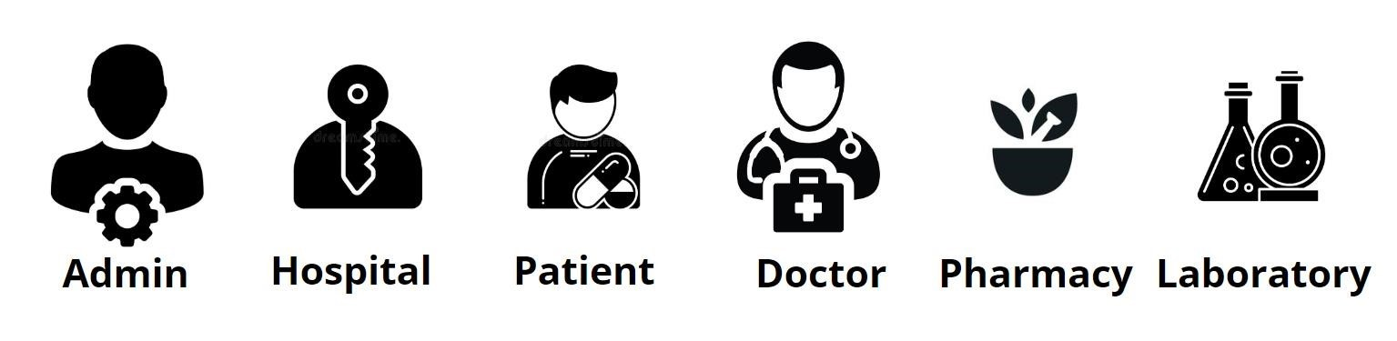

Fig.1. Different users in Hospital Management

## IV. IMPLEMENTATION

Modules based on our hospital management system.

A. Admin: This is the main admin portal here admin can add new hospital and will get an overall user details in the dashboard for analytical purposes. there is an approval pages set for those clients such as clinics, laboratory, pharmacy that make a registration online.

B. Hospital: This is the sub admin portal here hospital admin can add their employees such as doctors, lab admin and pharmacy admin. Webpage also provide an overall user details in the dashboard for analytical purposes.

C. Patient: Here in patient portal, patients during their registration they are provided with a QR code as a unique identification. This QR is used at doctor, pharmacy and laboratory for patient identification the details provided by the doctor is stored in the patient database in a reverse chronological order and act as patient history.

D. Doctor: Doctor are able to see the medical history of patients by scanning the QR code in their portal. They are given options to add prescription as well as recommend laboratory test. After successful access of medicines and lab results the data is stored into patient database as patient history for further references.

E. Pharmacy: Here in pharmacy portal they are able to identify the patient from the QR code and the medicines prescribed by the doctor is visible, once the medicines are given to the patient they can confirm the purchase of the medicines which stores the detail in patient medical history.

F. Laboratory: Here in Laboratory portal they are able to identify the patient from the QR code and the lab test prescribed by the doctor is visible, once the results are produced they can upload the result into patient database and confirm on complete which can be visible from patient medical history.

G. Software Implementation:

For efficient web application we are using python with Django, Django is a high-level framework for web which provide rapid development and clean design.

### **5. RELATED TECHNOLOGY**

1. Python

Python is a high level, object oriented, interpreted, general purpose programing language with dynamic semantics. It is very attractive to rapid applications due to its high level built in data structure, combined with dynamic typing and dynamic binding as well as it is also used to connect existing components together. It reduces the cost of program maintenance due to its easy learnable syntax. It encourages program modularity and code reuse by supporting modules and packages. the edit-test-debug cycle is incredibly quick here.

1. Django

It is an advance web based framework written in python that make use of the model view controller architecture pattern, it had been created during a fast paced newsroom environment ,and its key objective is to ease the development of complicated , database driven website, it is available as an open source web frame work and uses python extensively to create files , settings and data models it was mainly focus to solve two main challenges, the desperate requirement of highly expertise web developers and the intense deadlines of busy work environment .it concentrates more on automating possible areas.

1. SQLite

SQLite could even be a process library that implement a self-contained, zero configuration, server less, Transitional SQL database engine. The source code exists in public domains and is free for both private and commercial purposes. It has binding to several programing languages like C, C++, java, C#, and as for our requirement it has binding towards python also SQLite is ACID compliant (A- atomicity, C- consistency, I- isolation, D- durability).

### **6. SYSTEM REQUIREMENTS**

The main goal in this work is to create a web-based portal that can ease the healthcare providers. hence the main requirement is the storage to store the huge amount of each individual data that use this service, since it is a centralises storage concept for easy data retrieval this can be a huge storage area depending on the implementation strategy. And to make the retrieval quick the deployment must be of nearby region for smooth working of hospitals. As this is a scalable work depending on the requirement the depended parameters should also be able to expand such as storage type, processing power etc. there should be a complete secure, reliable network which guarantee to not interrupt the smooth working environment of the user so that the service is available all around the clock without any inconvenience.

### **7. WORKFLOW**

This project initially deals with a user portal for every module in its own different context. Each individual user has to login to interact with project UI. Once a new patient register into our web interface they are provided with a QR code. Now this QR code can be used to access in variety of hospital facilities throughout the journey. Patient portal provided with useful features like health status, medicine timing, medicine history and lab reports. After successful registration patient can access these features in there portal by login with their username and password. In similar context to the patient portal, doctor can access patient database with the QR code provided to the patient during registration. Here doctor can directly access patient database just to insert prescriptions, special notes, symptoms and send request for lab test to laboratory through patient QR code. Doctor login with universal doctor id along with their unique username and password. Doctor can only access the portal at hospital working hours. Our project deals with the dynamic situation that arise in the hospital premises especially around laboratories and pharmacy. In laboratory their portal handle with uploading patient lab reports into the patient database. Here patient is identified using the unique QR code that each individual owns. The lab tests are performed from the request by the doctor through the patient portal. Once the report is being uploaded this can be viewed by the patient and can be observed by the doctor in the next visit. In the busy environment of pharmacy for the patient convenience, once the doctor prescribes medicines to the patient database, a request to send in prior to pharmacy for as to avoid chaos. Pharmacist can organise and keep the prescribed medicines before the patient arrive. Patient are identified with the unique QR code that they own. Admins are responsible for the entire working of the hospital. They are the one who provide access to doctor, laboratory and pharmacy and can access patient’s database to filter out patients with parameter that is in context with situation.

BLOCK DIAGRAM OF HOSPITAL MANAGEMENT SYSTEM

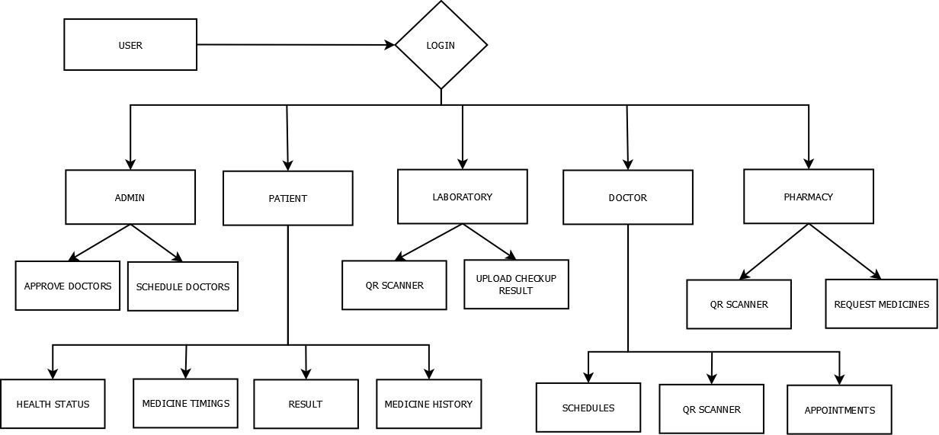

### **8. RESULT**

Our Project make a difference in current hospital situations. This project is fir for such a dynamically challenging environment. This project is patient centric as well as organisation friendly. It serves in both ways without any biasing. database filtering feature is one of the most requirement in our current era to monitor the disease outbreaks which happen unexpectedly. Each hospital has its own individual database managed by a admin which prevents any data breach. The unique QR code provided to each patients makes it easy to identify the patient at different services within the hospital. Bringing QR code into the project makes it easy for the patients to reduce effort of staying in long queue for consulting doctors. Web app will help the patient to view their lab reports and medicine notes. So that patient need not be aware about the written prescription and hard copy of lab reports. All these data are stored in the database hence can be viewed any time and future consultation becomes easy.

### **9. CONCLUSION**

This project is perfect for the dynamic environment of a healthcare service providers cutting down the managing time that usually requires a manpower and high cost. This project helps in reducing the crowd that usually happen in such environment which is convenient for both patient as well as organisation. This project is done in Django which is perfect for such huge database and can be quickly modified according to the requirement without any expertise.

### **10. REFERENCES**

1. Priyanka Patil, Sruthi Kunhiraman, Rohini Temkar: Functional Description of Online Medical Management System Using Modern Technology.
2. Fatma Poni Mardiah , Mursyid Hasan Basri: The Analysis Of Appointment System To Reduce Outpatient Waiting Time At Indonesia’s Public Hospital
3. Xiaojun Zhang A1, Dr. Ping Yu A2: Developing an Online Patient Appointment Scheduling System Based On Web Services Architecture
4. Aakash Chhatlani, Aanchal Dadlani, Meet Gidwani: Portable Medical Records Using Internet of Things for Medical Devices
5. Prof.D.V.Chandran , Sayali Adarkar , Apurva Joshi, Preeti Kajbaje: Digital Medicine: An Android Based Application For Health Care System
6. Fayezah Anjum, Abu Saleh Mohammed Shoaib, Abdullah Ibne Hossain: Online Health Care
7. Paschou Mersini, Evangelos Sakkopoulos, Athanasios Tsakalidis: Appification of Hospital Healthcare and Data Management Using Qrcodes